Good afternoon, everyone. Today, I will be presenting on Aidoc’s Stroke Package / solution, which is an advanced AI tool designed to enhance the detection and management of stroke.

According to The World Health Organization estimates, 15 million people worldwide suffer a stroke annually. Of these, 5 million die and another 5 million are left permanently disabled, placing a burden on family and community.

Stroke is uncommon in people under 40 years; when it does occur, the main cause is high blood pressure. However, stroke also occurs in about 8% of children with sickle cell disease.

High blood pressure and tobacco use are the most significant modifiable risks.

The incidence of stroke is declining in many developed countries, largely as a result of better control of high blood pressure and reduced levels of smoking. However, the absolute number of strokes continues to increase because of the ageing population.

Examining CT and MRI scans is crucial in the diagnosis and management of stroke. These imaging techniques help identify the type, location, and extent of brain damage caused by the stroke.

CT Scans: They are often the first imaging test performed in suspected stroke cases. CT scans can quickly detect bleeding in the brain (intracranial hemorrhage), which is essential for determining the appropriate treatment. They can also identify large-vessel occlusions (LVO) and other abnormalities.

MRI Scans: MRI provides more detailed images of brain tissue compared to CT scans. It is particularly useful for detecting ischemic strokes (caused by blood clots) and small or medium-vessel occlusions (MEVO). MRI can also reveal the extent of brain damage and help in assessing the prognosis.

However, examining CT and MRI scans can be time consuming and challenging, that’s why we need radiologists as a type of specialist to do this work.

In addition, the number of CT and MRI examinations in Australia has been increasing over the years. In 2022–23 financial year, there are 29.7 millions of Diagnostic imaging Services has been done in Aus (include X-rays, CT scans, ultrasound scans, MRI scans and nuclear medicine scans)

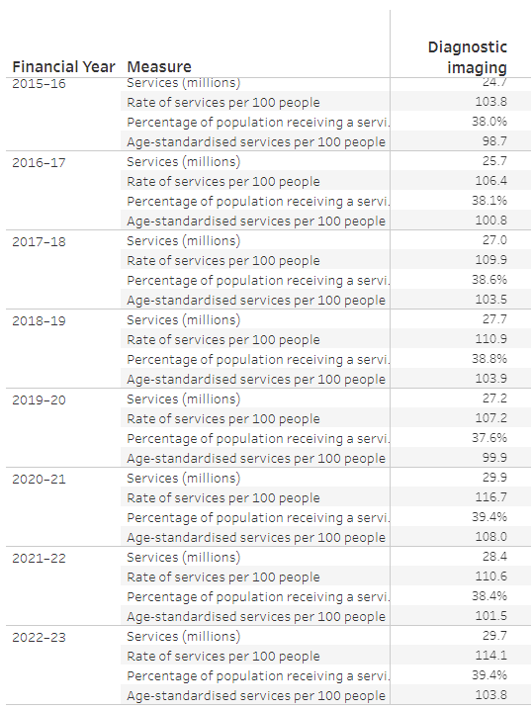

<https://www.aihw.gov.au/reports/diagnostic-services/pathology-imaging-and-other-diagnostic-services>

More images per scan; turnaround & quality demands make this work more and more challenging.

Aidoc’s Stroke Package is based on two-stage algorithm:

The first stage is a 3D deep convolutional neural network (CNN) that was trained on tens of thousands CTs acquired on a diverse range of CT scanners from multiple medical centers around the world. This network is trained on segmented scans and produces a 3D segmentation map. From the segmentation map, region proposals are generated and passed as the input to the second stage of the algorithm.

The second stage classifies each region as positive or negative, based on features from the last layer of the first stage and traditional image processing methods. When detect a suspected positive finding, the solution will deliver notification directly to the radiologist end (workstation or cell phone).

The software can be connected in a variety of manners to PACS and all relevant CT studies are automatically sent for analysis with no manual trigger. The software is vendor neutral and is FDA cleared/CE marked for use on multiple scanners from multiple manufacturers.

Talking about **Regulatory Approvals.** FDA approved, CE marked, and ISO certified

These certifications ensure that the tool meets strict safety, efficacy, and quality standards, making it a trusted solution in clinical practice.

The Aidoc company reports having 17 FDA-cleared algorithms in radiology across various pathologies. After checking description, at least 6 of algorithms are directly work on CT or CTA images

Thus the Comprising AI modules can detect

- Intracranial Hemorrhage (ICH) [ˌɪntrəˈkreɪniəl] [ˈhemərɪdʒ]

- Large Vessel Occlusion (LVO) [əˈkluːʒn]

- Medium-Vessel Occlusion (MEVO)

- 颅内出血 (ICH)

- 大血管闭塞 (LVO)

- 中血管闭塞 (MEVO)

Target Users:

- radiologists

- emergency physicians [fɪˈzɪʃən] 内科医生

Target Patients:

- patients with suspected stroke

AWS (Amazon Web Services ) and aidoc

<https://aws.amazon.com/solutions/case-studies/aidoc-case-study/>

integrate into PACs or RIS

According to a 2021 survey of U.S. hospitals, 90 percent have an AI strategy in place—up from 53 percent in 2019—yet implementation lags behind with only 34 percent deploying an AI solution. As these strategies are introduced at the dawn of AI in healthcare, many existing AI “marketplaces” lack the true unifying quality required to integrate and orchestrate multiple AI solutions—at scale and seamlessly—due to the technical limitations imposed by vendor incompatibilities. Aidoc’s AI OS helps solve these technical barriers of using AI at scale by orchestrating a diverse set of AI solutions under one unified, vendor-agnostic operating system. The OS applies unique AI-based image analysis to match the most compatible algorithm with the relevant scan and ensure improved quality of care.

根据 2021 年对美国医院的调查，90% 的医院已经制定了 AI 战略（高于 2019 年的 53%），但实施工作却落后，只有 34% 的医院部署了 AI 解决方案。由于这些战略是在医疗保健领域 AI 刚刚兴起时引入的，许多现有的 AI“市场”由于供应商不兼容造成的技术限制，缺乏真正统一的质量，无法大规模无缝地集成和协调多种 AI 解决方案。Aidoc 的 AI OS 通过在统一的、与供应商无关的操作系统下协调多种 AI 解决方案，帮助解决了大规模使用 AI 的这些技术障碍。该操作系统应用独特的基于 AI 的图像分析，将最兼容的算法与相关扫描相匹配，并确保提高护理质量。

Aidoc’s comprehensive suite of AI includes solutions for triage and detection of acute patients and AI-driven cross-specialty workflows facilitating care coordination. Along with 7 FDA-cleared solutions for intracranial hemorrhage, acute C-spine fractures, intra-abdominal free gas, rib fractures, large vessel occlusions, and pulmonary embolism on both dedicated and non-dedicated (incidental) exams, the Aidoc OS platform integrates AI solutions from Imbio, Riverain, Icometrix, Subtle Medical and ScreenPoint Medical, together covering a variety of radiology subspecialties and imaging enhancements.

Aidoc 的综合 AI 套件包括用于对急性患者进行分类和检测的解决方案以及促进护理协调的 AI 驱动的跨专业工作流程。除了七种经 FDA 批准的解决方案（用于颅内出血、急性颈椎骨折、腹腔内游离气体、肋骨骨折、大血管闭塞和肺栓塞（专用和非专用（偶然）检查））外，Aidoc OS 平台还集成了来自 Imbio、Riverain、Icometrix、Subtle Medical 和 ScreenPoint Medical 的 AI 解决方案，共同涵盖了各种放射学亚专业和成像增强功能。

Rapid treatment of stroke is vital to improving outcomes,

where fast detection means patients can be taken to a stroke centre in time to save their lives.

for example, the American Stroke Association and American Heart Association run a joint programme focused on improving ischaemic stroke care by reducing ‘door-to-needle’ time, the time from detection of a stroke to treatment to remove the blood clot.

Aidoc accelerant the radiologist’s workflow with life-saving technology, assuring medical providers that there are no delays in treatment for patients suffering from a stroke – be it hemorrhagic or ischemic.”

The stroke package, comprising the new CE-marked large-vessel occlusion AI module and Aidoc’s already FDA-cleared and CE-marked intracranial haemorrhage AI module reduces ‘door-to-needle’ time for patients suffering from stroke, improving outcomes and saving lives.

FDA-cleared and CE-marked pathology algorithms

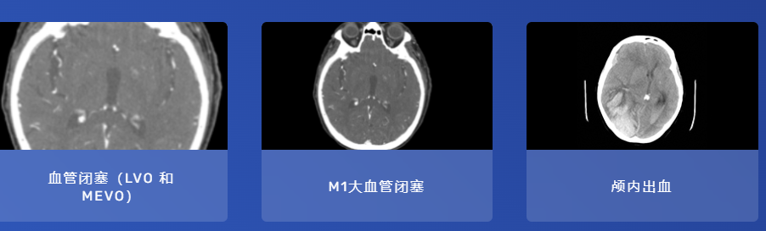

CTP stands for Computed Tomography Perfusion 计算机断层扫描灌注

Right MCA territory refers to the area of the brain supplied by the right Middle Cerebral Artery.

右侧 MCA 区域是指由右侧大脑中动脉供血的大脑区域

So, “CTP mean transit time in the right MCA territory” means measuring the average time it takes for blood to flow through the brain tissue supplied by the right middle cerebral artery using CT perfusion imaging. This information is crucial in assessing brain perfusion, especially in cases of stroke or other cerebrovascular conditions.

因此，“右侧 MCA 区域的 CTP 平均通过时间”是指使用 CT 灌注成像测量血液流经由右侧大脑中动脉供血的脑组织所需的平均时间。这些信息对于评估脑灌注至关重要，尤其是在中风或其他脑血管疾病的情况下。

However, the classification of AIH is contingent on the opinion of experts, and the training of the system depends on the labelling of AIHsuspected areas by experts. As such, discordance between experts regarding the final classifications or labelling of images is inevitable.

然而，AIH的分类取决于专家的意见，系统的训练取决于专家对AIH疑似区域的标记。因此，专家之间对图像的最终分类或标记的不一致是不可避免的。

In addition, poorly defined characteristics, variability in sizes and morphologies, and the attenuation of AIH contribute to inter-observer discordance even between expert neuroradiologists.

外，特征定义不明确、大小和形态的多变性以及 AIH 的衰减甚至导致专家神经放射学家之间的观察者之间的不一致。

In this regard, an anomaly detection process based on unsupervised training alongside a haemorrhage detection process can overcome the drawbacks of the supervised haemorrhage detection process used in conventional AI algorithms for intracranial haemorrhage detection, leading to an improvement in diagnostic performance18–22.

在这方面，基于无监督训练的异常检测过程与出血检测过程相结合可以克服传统 AI 算法用于颅内出血检测的监督出血检测过程的缺点，从而提高诊断性能 18–22。

Recent studies have proposed new deep learning architectures based on a joint recurrent neural network (CNN-RNN) approach with promising results, highlighting its potential for assisting radiologists and physicians in their

clinical diagnosis workflow15,27

最近的研究提出了基于联合循环神经网络 (CNN-RNN) 方法的新型深度学习架构，并取得了良好的结果，凸显了其在协助放射科医生和医生进行临床诊断工作流程方面的潜力15,27